RWMapMaker Manual

Version 1.0

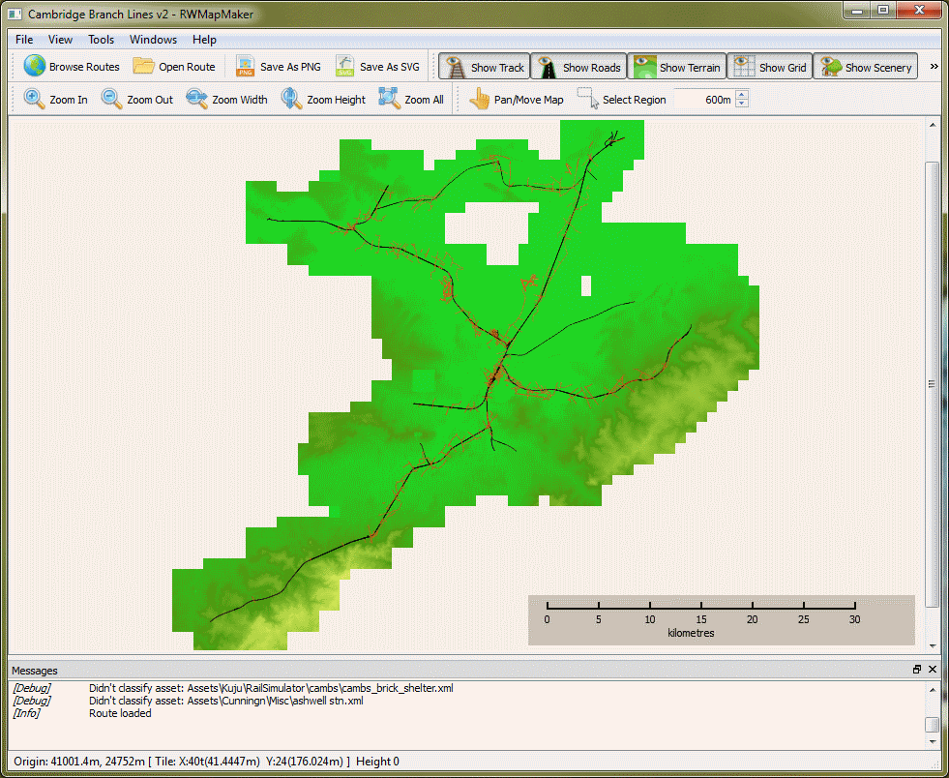IvimeyCom

# Introduction

RWMapMaker is a tool that creates a 2D map of a Train Simulator 2013 Route on your computer’s monitor. The map can include a representation of the height of the land, the roads and railways within the route, and the location (but not detailed shape) of many of the houses, trees, factories and other structures placed within the route.

There are also some not-so-obvious things that can be shown, including the boundaries of the tile files that are used by Train Simulator 2013 to store the route, the origin, to which all coordinates are referenced. You can also read off the status bar the exact location of the mouse pointer of any point in the route.

In this document, “Train Simulator 2013” and “TS2013” refer to the game program created by Railsimulator.com. RWMapMaker is an independently created addon to that game. All Copyrights and Trademarks belong to their respective owners.

## Why?

RWMapMaker has been created as an aid to route-building using Train Simulator 2013:

* As a way to get an overview of the route, what has been built and what is lacking;
* As a way to quickly locate tiles in the route (to find out that “problem in tile 3,7” means a problem at Smith Junction);
* As a way to get maps and plans for inclusion in manuals and web material;
* And just to see and admire what has been done!

As development has proceeded, some other uses have become apparent:

* It parses the Train Simulator 2013 files using an independently created tools, so it can log issues that Train Simulator 2013 does not report, making problems easier to locate;
* There are opportunities to “mine” the information loaded from the route, for example to visually locate objects. While this is not done in the current version, it is likely to be in a subsequent version.

# Requirements

To run RWMapMaker you will need a computer running Microsoft Windows, as is true for TS2013 itself. The program has been tested on Windows 7, both 32-bit and 64-bit, and should work on Windows 7, Windows 8 (Desktop mode only) and Windows Server 2008. It may work on Windows XP (32-bit) but this is not guaranteed or supported.

The computer must have access to the installation folder of TS2013. RWMapMaker uses the program “serz.exe”, found in the Train Simulator 2013 installation folder, to decode the route files, but it does not require an active Steam login.

Because of the large amount of data that must be loaded into memory at once, you will need at least ½ GB (500MB) of RAM available to the program when you run it, which suggests a minimum installed RAM of 1GB.

The map is presented as a zoom-able and pan-able image on your screen in a similar way to Google Earth and Bing Maps. For the game itself, a reasonably good graphics card will help keep the display snappy, but this is not critical to operation.

Parts of the program take advantage of multiple CPU cores where this is possible, but a fast disk system is also fairly important.

A minimum spec for this program is regarded as:

Intel Core 2 (or equivalent) CPU running at 2GHz.

1GB RAM;

An Aero-capable display system;

48MB free disk space for the installation;

Windows 7 or Windows 8; 32-bit or 64-bit

A Recommended spec for this program is:

Intel Core i5 CPU running at 2.8GHz or better.

4GB RAM or better;

An Aero-capable display system;

48MB free disk space for the installation;

A very fast hard drive or an SSD;

Windows 7 or Windows 8 in 64-bit mode.

# Installation

The installation file is provided as an MSI or Microsoft Installer file. It can be installed by opening it on any current version of Windows. It will prompt for an installation location in the normal “wizard” style and place a program start shortcut in the IvimeyCom sub-folder.

To start RWMapMaker, invoke the program shortcut. When you do this for the first time, you can chose whether to run the program in Trial mode, or to enter the license key you bought with the download.

# Activation

When you enter your license key, RWMapMaker will activate the key to that computer over the internet.

Make sure that the computer you are running it on is the one you would normally wish to use it on, and that you have an internet connection at that time.

After activation, RWMapMaker neither needs nor uses the internet, and will only use a network if you explicitly browse to a networked folder when using one of the file dialogs.

The activation process sends a Hardware id, derived from your PC’s hardware configuration, the Product key, and the details you enter – Name and Email – as a record of your product. No other information about you is stored.

# RWMapMaker Operation

Start the program by running the shortcut under Programs > IvimeyCom or by opening the executable file. The program does not associate itself with any data file type (in the way Word associates with .doc files).

On startup, you can either

* Open a specific route file, if you know in advance what it is
* Browse the installed Railworks routes

## Open Route

When you Open a Route file using Ctrl-O, the File menu or the toolbar, you use the File dialog to select the RouteProperties.xml file for that Route. An example location would be:

C:\Program Files\steam\steamapps\common\railworks\Content\Routes\ 00000002-0000-0000-0000-000000000000\RouteProperties.xml

When you open a route file in this way, you can chose to disable loading the terrain data for the route. Do this if you don’t need the terrain shown on the map, and wish to speed up load times.

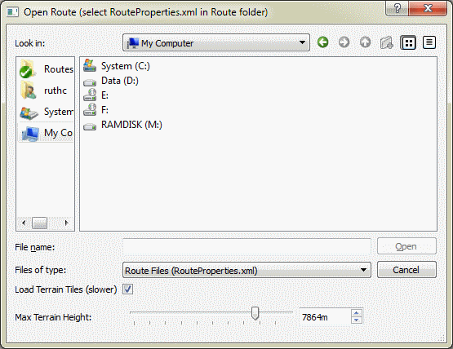

## Browse Routes

The Route Browse dialog is displayed. It will take a few seconds to find and load in the route information, which is displayed as a list, one line per route, within the dialog.

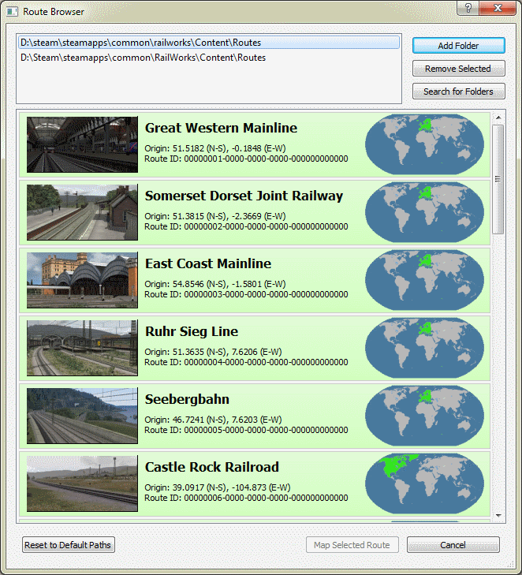

The information shown in the list includes:

* The Collection Centre image for the route, if that is found, or a default image if not;
* The Name of the route;
* The Latitude & Longitude of the Route’s Origin;
* The Route ID;
* The continental location of the route, as used by the TS2013 Route Filter.

At the top of the dialog, you can change the folder that the routes are loaded from, useful if you have multiple installations on your system. When Clicking “Add Folder” you must select the Routes folder within Content: no harm will be done if you don’t, but routes will not be loaded from other folders.

Clicking the Search button will cause RWMapMaker to try to find any routes on the system. It will not search network-attached drives and it won’t search very deep, on the grounds that it is unlikely to be found there . Thus:

“C:\a\b\c\d\e\railworks” will be found, but

“C:\a\b\c\d\e\f\g\h\i\railworks” won’t be.

Double clicking on a route, or single-clicking and then clicking Open, will load the route.

## Route Loading

To load a route, it is necessary to load data for each and every tile the route has, and for each of the 4 types of data the program reads. A tile is a 1024 metre square area of of the route.

During Route Loading, a dialog is displayed that shows the number of tiles that must be loaded for each type of world data, and a progress bar will enumerate these as they load.

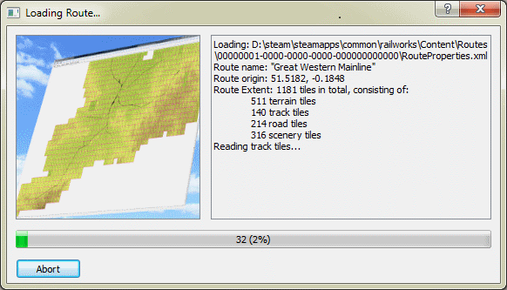

Currently the following types of data are considered:

* Track
* Roads
* Terrain Height
* Scenic Assets (type and location)

The following information is currently ignored:

* Terrain color and texture (the “Mixmap”)
* Lofts (embankments, fences, etc)

In addition, no attempt is made to identify the actual size of scenic items, though an attempt is made to classify them using their blueprint name, and then assign a size based on that classification.

If you wish to abort the route loading process, click on the Abort button on the left corner; within a second or so the loading should terminate and any data that has been loaded will be discarded.

## The Map Display

Once the route has loaded the display will be updated to show the complete map, as shown below.

Depending on the view options you have selected, this may include terrain, road, rail and scenery items, the route origin and the tile grid. If you cannot see much at this point, check the View Toolbar or the View Menu to see the selected options.

The full set of map items supported are:

* Track: the path of each segment of track in the route, from the tile files.
* Road: the path of each segment of road in the route.
* Terrain: the height of each point in each of the terrain tiles, mapped to a colour.
* Grid: The borders of the tile grid, which is aligned to the origin.
* Grid Address. The x,y address of each grid tile, centred within the tile.
* Origin: A large purple “star” located at the route origin, which is also at the left, bottom of tile 0,0.
* Scenery: A fuzzy dot of varying colour representing the location of a scenic item.



The Preferences dialog, on the View menu, has other options affecting the map display. Refer to for more information.

### Zoom

You can zoom in on part of the map using either the zoom buttons on the toolbar or menu, or by using the mouse wheel. The mouse wheel zooms somewhat less per “click” than the GUI buttons do. Use the Width and Height toolbar buttons to set the viewed map section such that the height of the window matches the height of the map, and also for width.

### Pan

You can pan the window by using the scrollbars at the edge of the window, or by “grabbing” with the mouse (that is, left button down and move then release) – at least initially you can. There is a toolbar selection button that selects between the mouse panning the display and selecting an area of the display. Area selection is used for the Save functions.

### Pointer Location

If you look at the status line at the bottom of the window, you will notice that information about the current location of the mouse cursor is available, updated in real time as it is moved. This information is:

* The absolute position of the mouse pointer in metres from the origin;
* The position of the mouse pointer in tiles and metres within the tile;
* The height of the terrain in metres above sea level at that point;

Note that for “negative” tiles, that is tiles south and west of the origin, the pointer location is still reported relative to the left-bottom corner of the tile (just as for other tiles).

### Tooltips

If you hover the mouse over an item such a track or scenic asset, additional information is available for it. When hovering, you must be quite accurate!

For track and road items, the information depends on exactly what the track is: a curve or straight, but it will include the network ID, the ribbon ID (track only), the length of that section, the initial direction, and the parameters of the curve.

For scenic items, the tooltip is the name of the asset blueprint.

## Terrain Display

The default terrain height mapping setup is designed for routes with a maximum height of 1000m above sea level. In the toolbar is a numeric entry widget that you can use to change this maximum height. For example, routes such as Marias Pass will need a value more like 4000 here. Currently it is not possible to modify the lower limit of the height map, which is set at -25m. Below and above the map limits, the colour of terrain is that of the minimum (if lower) or maximum (if higher) mapped colour.

Terrain height mapping can also be changed in another way: with an alternate colouration map. On the View menu you can select from the 4 preinstalled options. You can if you like make your own: these files are standard GIMP Gradient files and new ones will be found if you store them in the program’s user data area:

* C:\Users\%USER%\AppData\Roaming\IvimeyCom\RWMapMaker\gradients

RWMapMaker copies the default files into that folder if it doesn’t exist, and thereafter only reads them.

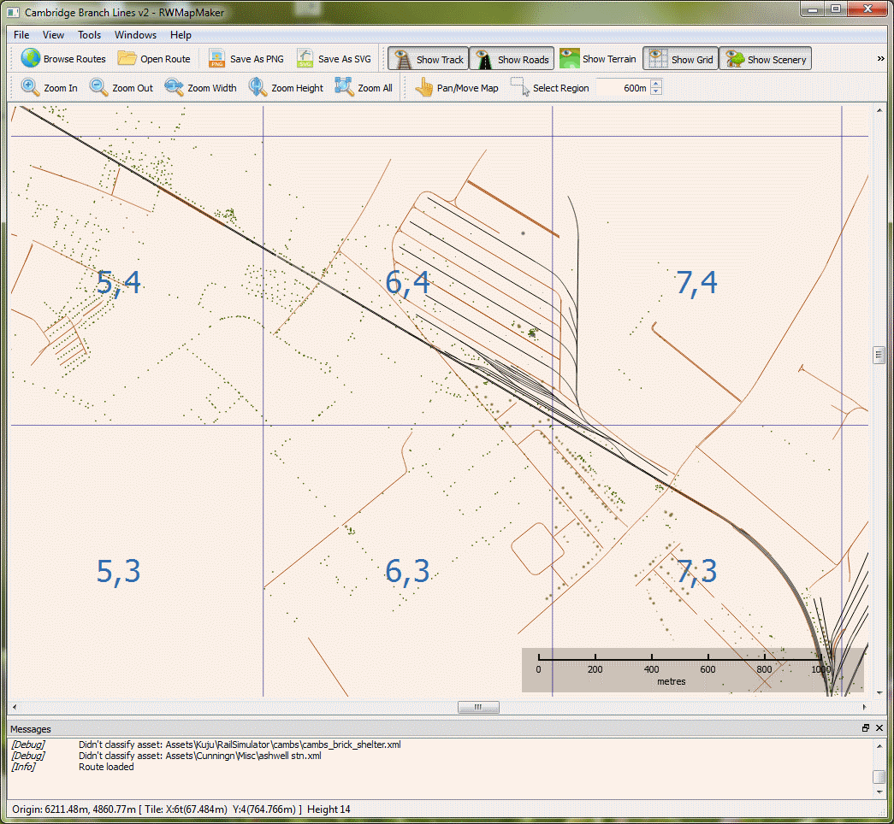Example display showing rail, road and asset locations without terrain backing.

## Saving Images

You can save a map view to a file for reference using the Save As PNG or Save As SVG menu options. PNG is a common pixel-based image file format that saves files in a lossless way. SVG is a common vector file format that saves each line and shape as a line or shape, making it possible to scale such images without loss of quality. Note that the terrain height map is by definition a pixellated item.

To save the whole map as a PNG file, click on Save As PNG, select a folder and filename in the file dialog, optionally set the resolution (in pixels per kilometre of ground), and click on OK.

When saving, the view options applied when the save is initiated are used. So for example if you wish to see the grid boundaries in the saved image, select it in the map view beforehand.

Resolution may need more explanation: as a pixel format, RWMapMaker needs to know how big the resulting PNG image will be. Rather than select an overall image size, RWMapMaker calculates the size based on how many pixels in the final image you want to represent 1 kilometre. For example, a one tile route with the value 1000 in pixels/kilometre will result in a 1000x1000 pixel image. Reducing the value will reduce the size of image created.

If you ask to save an image that is too large, RWMapMaker will tell you and abort the save. Too large could mean either:

Larger than 1.5GB of memory needed (that is, uncompressed size);

Larger than 32760 pixels in either width or height.

RWMapMaker will warn you if the image is more than 250MB in size, just to check that you meant it, but cancelling the save is optional at this size.

If you want to save a part of the image rather than the whole map, use the Select Region button on the toolbar to change mouse mode, and then draw a region on the map view. Having done this, select Save As PNG and continue as above: only the region selected will be saved to file.

Saving the file in SVG format is similar, though there is no need to select a resolution as SVG is resolution independent.

Saved SVG files rapidly get very large and may exceed the ability of your graphics editor to read them. You are advised to use the Select Region function (as for PNG saves) to determine the usable limits.

# Preferences

A number of preference values are available in the preference dialog, on the Tools menu. Many of these affect the way that the map is drawn. Some affect the way the program deals with the route files themselves.

The Preferences dialog has 3 pages, Colours and Fonts, Locations and Advanced.

## Colours

The Colours and Fonts dialog includes most of the controls affecting the appearance of the map display. On the left hand side are buttons controlling the colour of various parts of the map, and on the right hand side are controls selecting element text font and the way in which track and road lines are displayed.

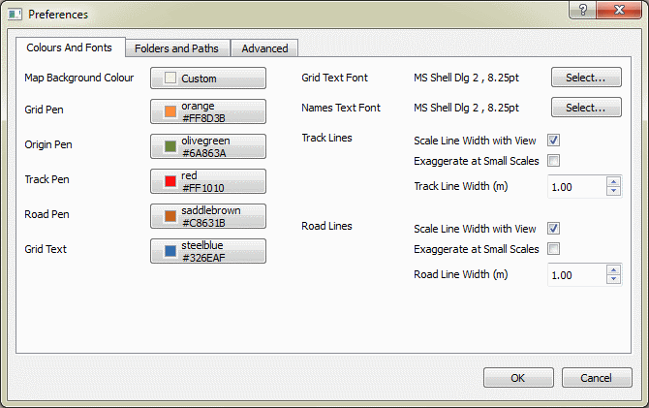

The colours are:

Map Background Colour: The colour of the map where there is no terrain – both inside and outside the modelled area;

Grid Pen: The colour of the grid lines, when displayed;

Origin Pen: The colour of the lines used to draw the route origin “star” shape;

Track Pen: The colour of the lines used to draw railway track;

Road Pen: The colour of the lines used to draw roads (and things considered by TS2013 to be roads, such as pathways);

Grid Text: The colour of the text showing the grid square “address” or location.

The other controls are:

Grid text font: The font used to display the Grid Text;

Names Text Font: The font used for the map scale;

The Track Lines and Road Lines groups control the way track and roads are displayed:

Scale Line Width with View: If checked, the Line Width controls the width in metres of the line, which is scaled according to the zoom level. If not checked, the lines will always be 1 pixel wide, whatever zoom level is used.

Exaggerate at Small Scales: If Scale Line Width is checked, the Line Width is made larger when the map is zoomed out, so as to keep the lines more visible;

Track/Road Line Width: The width, in metres, of the lines used to represent track and road (only applies if Scale Line Width with View is enabled).

## Folders and Paths

The Folders and Paths page holds settings that should normally be left at the defaults, but can be used to control which TS2013 files are used.

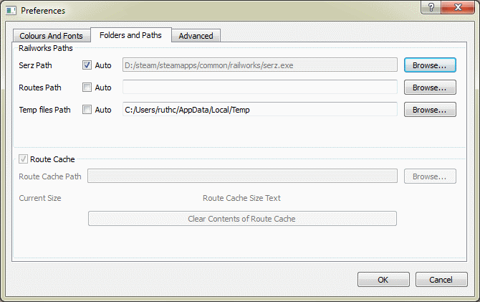

The Railworks Paths group contains three controls that behave the same way:

Serz Path: This specifies where the serz.exe program is located. It is distributed with TS2013 and is used to decode the Route files.

Routes Path: This controls which Routes are used.

Temp files Path: While reading route and asset files, RWMapMaker has to write a temporary file out with the decoded file. This folder specifies where that file is written.

For all three, checking the Auto checkbox tells RWMapMaker to do its best at select a suitable value automatically. If Auto is not checked, you can Browse for a location using the button at the right hand side, or enter the location directly.

The Route Cache feature is not enabled.

## Advanced

On the Advanced tab are a few additional controls which may be of assistance.

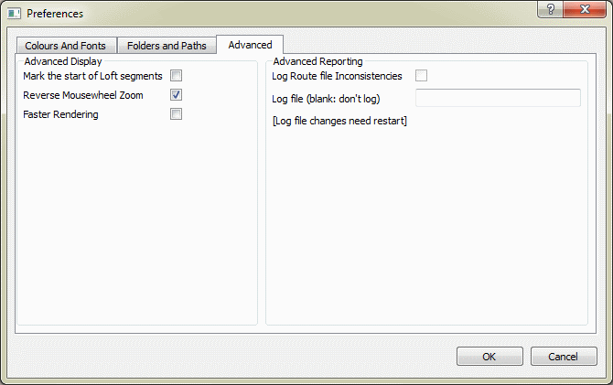

They are:

Mark the start of Loft segments: If checked, a small circle marks the start of a loft segment as it is drawn in the map. This is mostly a debugging aid.

Reverse Mousewheel Zoom: This reverses the action of the mousewheel zoom, so that the rotation that used to zoom in will zoom out, and vice versa.

Faster Rendering: This disables antialiasing of the map display, which assists slower processors and should improve the interactive experience. Leave disabled unless you are experiencing problems.

Changes in Preferences are applied when you click OK on the dialog, and discarded when you click Cancel.

### RAM Disk

It is possible to configure some of your computer’s memory as a RAM disk, and doing so will help make the system load routes faster if you also set the “Temp files Path” to a location on the RAM Disk.

An example of a RAM Disk product is available from Dataram. For the purposes of RWMapMaker you need no more than 100MB – and probably less – RAM dedicated to the Disk.